**Βήμα1**

**1/ API developer page**

* Twitter - <https://developer.twitter.com/>
* My API Developed ID: Krhtikoss
* Post, retrieve and engage with Tweets: GET statuses/oembed
* What does the API do?
  + Returns a single Tweet, specified by either a Tweet web URL or the Tweet ID, in an oEmbed-compatible format[1]. The returned HTML snippet will be automatically recognized as an Embedded Tweet when Twitter's widget JavaScript[2] is included on the page.
  + Resource URL(εδω που θα βρω όλες τις παραμέτρους): <https://developer.twitter.com/en/docs/tweets/post-and-engage/api-reference/get-statuses-oembed>
  + Δε χρειάζεται authentication

**Βήμα2**

a)Targeted tweet:https://twitter.com/uaegean/status/859355734622052352/photo/1

b)API TEMPLATE

|  |  |  |
| --- | --- | --- |
| GENERIC PARTS | SPECIFIC PARTS | DESCRIPTION |
| https://publish.twitter.com/oembed |  | This is where the API is located. |
|  | url=https://twitter.com/uaegean/status/859355734622052352/photo/1 | Specific link of the post we want |
|  | maxwidth=550 | Controls the maximum width of a Tweet |
|  | hide_media=false | Boolean of whether to expand associated links |
|  | hide_thread=false | Boolean of whether to show display the previous tweet in a conversation |
|  | omit_script=true | Boolean of whether to include the Javascript widget interface on the webpage |
|  | align=center | Set the alignment of the API (Left, Right, Center) |
|  | related=false | Displays a list of names separated by commas that is related to your content |
|  | lang=el | Affects the returned language of the API |
|  | theme=light | Controls the display of the tweet (light, dark) |
|  | link_color=blue | Adjusts the link text color |
|  | widget_type=false | Allows the display of a video widget. |
|  | dnt=false | Boolean of whether to include personalized suggestions and personalized ads |

3)Παράδειγμα

a)Request:

https://publish.twitter.com/oembed?url=

https%3A%2F%2Ftwitter.com%2Fuaegean%2Fstatus%2F859355734622052352&2Fphoto%2F1&maxwidth=550&hide_media=false&hide_thread=false&omit_script=true&align=center&related=false&lang=en&theme=light&link_color=blue&widget_type=false&dnt=false

Means url to be asked and embedded:https://twitter.com/uaegean/status/859355734622052352/photo/1

b)Response:

{

"url":"https://twitter.com/uaegean/status/859355734622052352",

"author_name": "University Of Aegean",

"author_url": "https://twitter.com/uaegean",

"html": "<blockquote class="twitter-tweet"><p lang="en" dir="ltr"ΡΟΔΟΣ: 8ο Συνέδριο φοιτητών / φοιτητριών &quot;Mare Nostrum VIII&quot; «Μεσόγειος: πεδίο μεταβλητής γεωμετρίας» 3-5 Μαΐ 2017 <a href="https://twitter.com/YosemiteNPS">@YosemiteNPS</a>. <a href="https://t.co/MMH1KG7clm\">https://t.co/MMH1KG7clm</a> <a href=\"https://t.co/Sc9vPYSfve\">pic.twitter.com/Sc9vPYSfve</a></p>&mdash; University Of Aegean (@uaegean) <a href="https://twitter.com/uaegean/status/859355734622052352?ref_src=twsrc%5Etfw\">May 2, 2017</a></blockquote>n<script async src="//platform.twitter.com/widgets.js" charset="utf-8"></script>"

"width": 550,

"height": null,

"type": rich,

"cache_age":"3153600000",

"provider_name": "Twitter",

"provider_url": "https://twitter.com",

"version": "1.0"

}

H ασκηση μου και στο Postman:

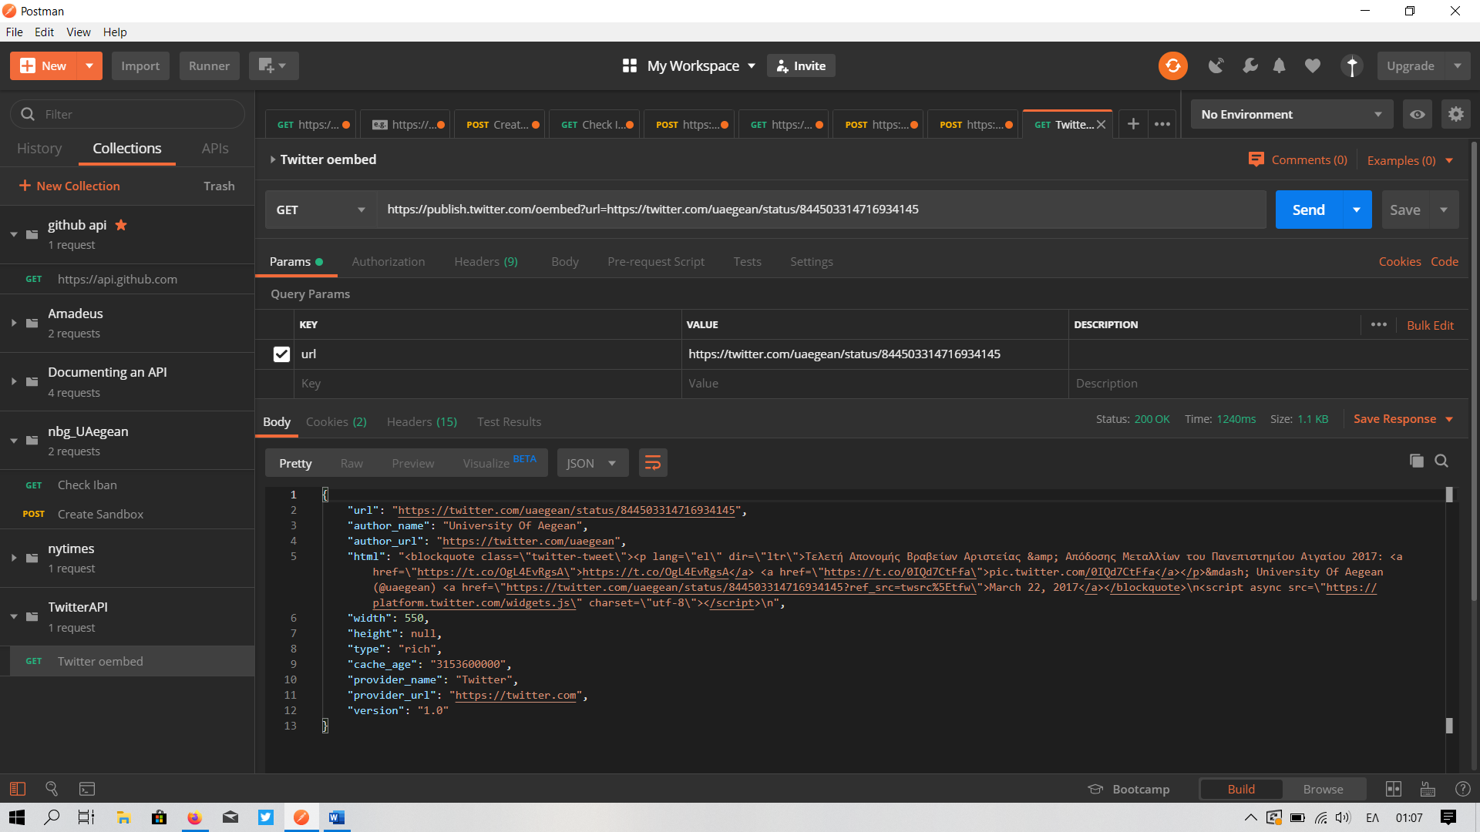

1.
2.